5.127: Before the horizontal string is cut, the ball is in equilibrium, and the vertical component of the tension force must balance the weight, so 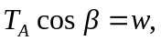 or 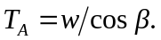 At point B, the ball is not in equilibrium; its speed is instantaneously 0, so there is no radial acceleration, and the tension force must balance the radial component of the weight, so 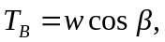 and the ratio 